DAR ES SALAAM INSTITUTE OF TECHNOLOGY

BACHELOR OF ENGINEERING IN COMPUTER ENGINEERING - NTA L7
ANALOGUE ELECTRONICS GROUP WORK GROUP MEMBERS:
SN | NAME | REGISTRATION NO
1 | ISMAIL MBAROUK SAID | 240242483521
2 | DEBORA BRYSON LEMA | 240242455798
3 | SALVATORY KILIMANJARO JAPHET | 240242403723
4 | FAHYIM HAMAD MASOUD | 240242495125
5 | TASIANA VITUS MLWALE | 240242412104
6 | FARAJA ANDROPH WILSON | 240242477818
7 | MUKTARI ABUBAKARI OMARY | 240242455491
8 | SIXBERTH SWEETBERTH MUGISHA | 240242405959
9 | ABUBAKAR HAMAD MSUMAI | 240242467561
10 | ESSAU JOSEPH QAMARA | 240242415115

- Kirchhoff’s laws
Kirchhoff's circuit laws are two equalities that deal with the current and potential difference (commonly known as voltage) in the lumped element model of electrical circuits. They were first described in 1845 by German physicist Gustav Kirchhoff.^{[1]} This generalized the work of Georg Ohm and preceded the work of James Clerk Maxwell. Widely used in electrical engineering, they are also called Kirchhoff's rules or simply Kirchhoff's laws. These laws can be applied in time and frequency domains and form the basis for network analysis.
Both of Kirchhoff's laws can be understood as corollaries of Maxwell's equations in the low-frequency limit. They are accurate for DC circuits, and for AC circuits at frequencies where the wavelengths of electromagnetic radiation are very large compared to the circuits.
- Kirchhoff's current law (KCL)
This law, also called Kirchhoff's first law, or Kirchhoff's junction rule, states that, “for any node (junction) in an electrical circuit, the sum of currents flowing into that node is equal to the sum of currents flowing out of that node”; or equivalently:
The algebraic sum of currents in a network of conductors meeting at a point is zero.
Recalling that current is a signed (positive or negative) quantity reflecting direction towards or away from a node, this principle can be succinctly stated as:
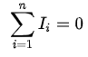
where n is the total number of branches with currents flowing towards or away from the node.
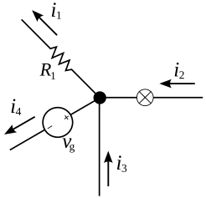
The current entering the junction is equal to the current leaving the junction: i₁ + i₄ = i₂ + i₃
- Kirchhoff's voltage law
This law, also called Kirchhoff's second law, or Kirchhoff's loop rule, states the following:
“The directed sum of the potential differences (voltages) around any closed loop is zero”
.
Similarly to Kirchhoff's current law, the voltage law can be stated as:

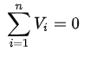
Here, n is the total number of voltages measured.

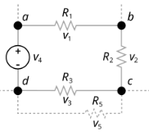
The sum of all voltages around a loop is zero: v₁ + v₂ + v₃ + v₄ = 0

- Procedures employed when analysing electrical circuits
The following are the step-by-step analysis of electric circuits involving Kirchhoff’s laws:
- Label the Circuit Diagram:
- Identify Nodes/Junctions: Mark and label all nodes (junctions where three or more wires meet).
- Identify Loops/Meshes: Identify all independent closed paths (loops or meshes) in the circuit.
- Assign Current Directions: Arbitrarily assign a unique current and direction to each independent branch. If the calculated current is negative, its actual direction is opposite to the assumed direction.
- Assign Voltage Polarities: For components like resistors, assign voltage polarity signs such that the current flows into the positive terminal and out of the negative terminal (passive sign convention). Voltage sources have fixed polarities.
- Apply Kirchhoff's Current Law (KCL) at the Nodes:
- For each independent node, write an equation based on the principle of conservation of charge: “the sum of currents entering the node equals the sum of currents leaving the node”
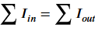
- Apply KCL to all but one of the essential nodes to obtain a set of independent equations.
- Apply Kirchhoff's Voltage Law (KVL) to the Loops:
- For each independent loop, write an equation based on the principle of conservation of energy: “the algebraic sum of all voltage changes (rises and drops) around the loop must be zero”
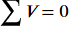
- Choose a direction to traverse the loop (clockwise or counter-clockwise) and consistently apply sign conventions: voltage rises (moving from - to + across a source or against current through a resistor) are positive, and voltage drops (moving from + to - across a source or with current through a resistor) are negative.
- Incorporate Ohm's Law:
- Use Ohm's Law (V=I×R) to express the voltage across each resistor in terms of its current and resistance, allowing you to create a system of equations solely in terms of unknown currents or voltages.
- Solve the System of Simultaneous Equations:
- You will have a system of linear equations from KCL and KVL applications. The number of independent equations should equal the number of unknowns.
- Use standard algebraic techniques (substitution, elimination, or matrix methods) to solve for the unknown currents and voltages.
- Verify and Analyse the Results:
- Check your answers to ensure they satisfy all the original KCL and KVL equations, and confirm the results are physically reasonable.
- Use circuit simulation software or alternative analysis methods (like Thevenin's or Nodal analysis) to cross-verify the results if possible

- Calculations on Kirchhoff’s Laws:
Question:
In the circuit shown in figure, find the value of current through 100 Ω.
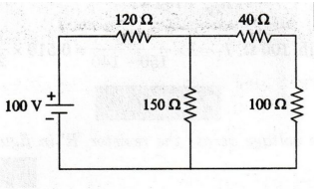
Solution:
We mark the currents as shown in the figure below
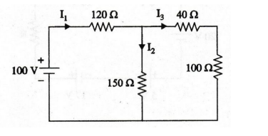
Then we find the equivalent total resistance.
For series connection:
40Ω + 100Ω = 140Ω
For parallel connection:
(150Ω × 140Ω) ÷ (150Ω + 140Ω) = 72.41Ω
For another series connection:
120Ω + 72.41Ω = 192.41Ω
From Ohms law:
I₁ = V ÷ R_{eq}
= 100 ÷ 192.41
I₁ = 0.519A
Now the current through 100Ω, I = 0.519 × (150 ÷ (150 + 140))
Current = 0.268A
Question:
Find the voltage across the resistor 'R' in figure.
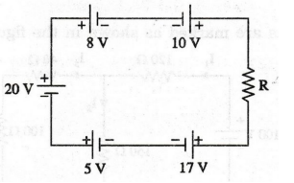
Solution:
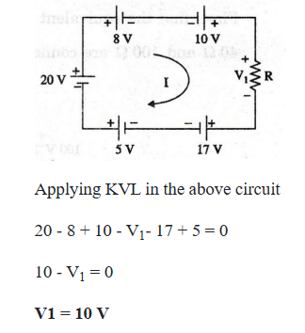
Question:
Find the current through 12 2 resistor in figure
Solution:
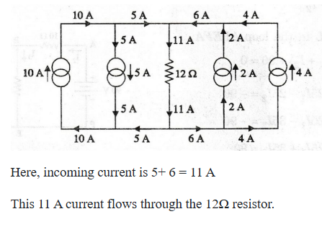
Question:
For the circuit shown in figure, determine the unknown voltage drop V₁
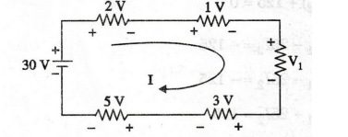
Solution:
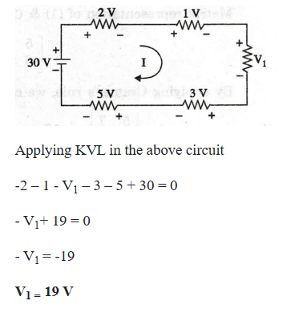
- Applications of Kirchhoff’s Laws:
Kirchhoff's Laws are fundamental to modern electrical engineering and are applied daily in countless devices and systems to ensure efficient and safe operation.
Kirchhoff's Current Law (KCL): The "Junction Rule"
KCL is based on the conservation of charge, stating that the total current entering any junction (node) in a circuit must equal the total current leaving it. This is like water flow in pipes; the amount of water flowing in must equal the amount flowing out
- Household Wiring (Parallel Circuits): In your home, multiple lights and outlets are connected in parallel to the main power line. The current from the main line splits at various junctions to power each appliance. KCL ensures the system is balanced, so the total current drawn by all connected devices equals the current entering the house's electrical panel, preventing overloads
- USB Chargers and Power Strips: When you plug multiple devices (phone, laptop, watch) into a single power strip or a multi-port USB charger, the main current from the wall outlet splits into different paths for each device. KCL is applied in the charger's design to guarantee that the sum of currents going to all devices matches the total input current, preventing overheating or damage.
- Printed Circuit Boards (PCBs): Inside electronic gadgets like smartphones or computers, complex PCBs have countless junctions where current is distributed among microchips, transistors, and other components. KCL is crucial during the design phase to ensure every component receives the correct current without overloading a specific trace (wire path).
- Electrical Grid Management: On a large scale, power engineers use KCL to manage the distribution of electricity across complex power grids. It helps balance the load, ensuring that power supplied from generators equals the power consumed by homes and industries, which prevents blackouts

Kirchhoff's Voltage Law (KVL): The "Loop Rule"
KVL is based on the conservation of energy, stating that the sum of all voltage changes (rises and drops) around any closed loop in a circuit must equal zero. This is analogous to a hike on a mountain; if you start and end at the same elevation, your total change in elevation is zero
- Battery-Powered Devices (Series Circuits): In a TV remote or a flashlight that uses multiple batteries in series, KVL helps determine the total voltage available to power the device. The sum of voltages from each battery equals the total voltage drop across the internal components (like the light bulb or electronic circuit)
- Automotive Electrical Systems: In a car, KVL is used to analyze the complex wiring for the headlights, radio, and engine control units. When troubleshooting a dim headlight, a technician can apply KVL to measure voltage drops across different sections of the circuit (wiring, fuse, switch) to pinpoint a poor connection or degraded wiring causing an unexpected voltage drop.
- Dimmer Switches and Voltage Dividers: Dimmer switches use KVL principles. They introduce a variable resistance in the circuit, changing the voltage drop across the switch itself. The remaining voltage across the light bulb is reduced, making it dimmer. This controlled voltage distribution ensures the bulb operates within safe limits.
- Electric Vehicle (EV) Battery Management Systems: In EVs, KVL is critical in Battery Management Systems (BMS). Engineers use KVL to monitor and balance the voltage across individual battery cells within a large battery pack, ensuring optimal performance, preventing overcharging/discharging, and enhancing the battery's safety and lifespan

